**Proposal for Development of   
Online Recruitment Portal (BDIntern)**

September 21, 2021

**Commercial Proposal**

|  |  |
| --- | --- |
| **Submitted To:** | **DEKKO ISHO TECHNOLOGIES LTD.**  Level#3, Suvastu Zenim Plaza  H#37, Road#16, Dhanmondi  Bangladesh |
| **Submitted By:** | **Sheba Technologies Limited**  95, Khawaja Tower, Bir Uttam AK Khandakar Road, Mohakhali, Dhaka 1212, Bangladesh. |

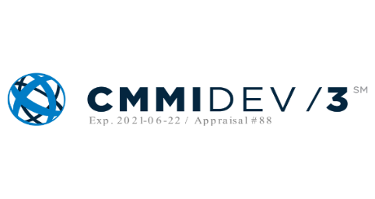

**PERPETUAL MODEL**

|  |  |  |  |  |  |
| --- | --- | --- | --- | --- | --- |
| **S.N** | **Particular** | **Unit** | **Price in BDT** | **VAT 5%** | **Total Price Inclusive VAT** |
| **A** | **Software Cost (One Time)** |  | | | |
| 1 | Online Recruitment Portal - BDIntern | 01 | 850,000.00 | 42,500.00 | 892,500.00 |
|  | **Total** | | | | 892,500.00 |
|  | In Words Including VAT | Taka Eight Lac Ninety Two Thousand and Five Hundred Only | | | |
| **B** | **AMC for the Solution** |  | | | |
| 1 | AMC Charge | 15% | 133,875.00 | 6,693.75 | 140,568.75 |
| **C** | **Future Change Request cost:** |  |  |  |  |
| 1 | Offsite Man days | Per Man Day | 7,000.00 | 350.00 | 7,350.00 |
| 2 | Onsite Man days | Per Man Day | 9,000.00 | 450.00 | 9,450.00 |

**PAYMENT PLAN**

**The payments shall be remitted by customer on the following basis:**

|  |  |  |
| --- | --- | --- |
| **Payment Terms** | **Interval (Tentative)** | **% of Total Payments** |
| **Project Kick off fee.** | **Advance** | **40%** |
| **Application GoLive** | **After application deployment** | **50%** |
| **Final Payment** | **1 Month After Application GoLive.** | **10%** |
| **Total % of Project Completion** | | **100%** |

**TERMS AND CONDITIONS**

* Purchaser (DEKKO ISHO TECHNOLOGIES LTD) shall issue a PO under the main contract between “Sheba Technologies Ltd.” and “DEKKO ISHO TECHNOLOGIES LTD”.
* Sheba Technologies Ltd. will issue the Invoice as per PO and main contract.
* Invoice & Payment will be made as per the payment terms.
* Support & Maintenance Fee will be applicable once full contract is awarded.
* Software Warranty period is 1 Year from successful UAT.
* AMC shall be charged at 15% per annum on the PO value.
* Any change in the scope or requirement will have cost implications and will be billed separately.
* Sheba Technologies Ltd. is a TAX exempted company, for which no AIT will be applicable in price quotation & payment.
* This commercial proposal is valid for 60 Days starting from the day of submission.
* Hardware and all other 3rd party licenses will be provided by the customer.